# All properties

Source code: TR_PHD/WOW_analysis/All_properties.R

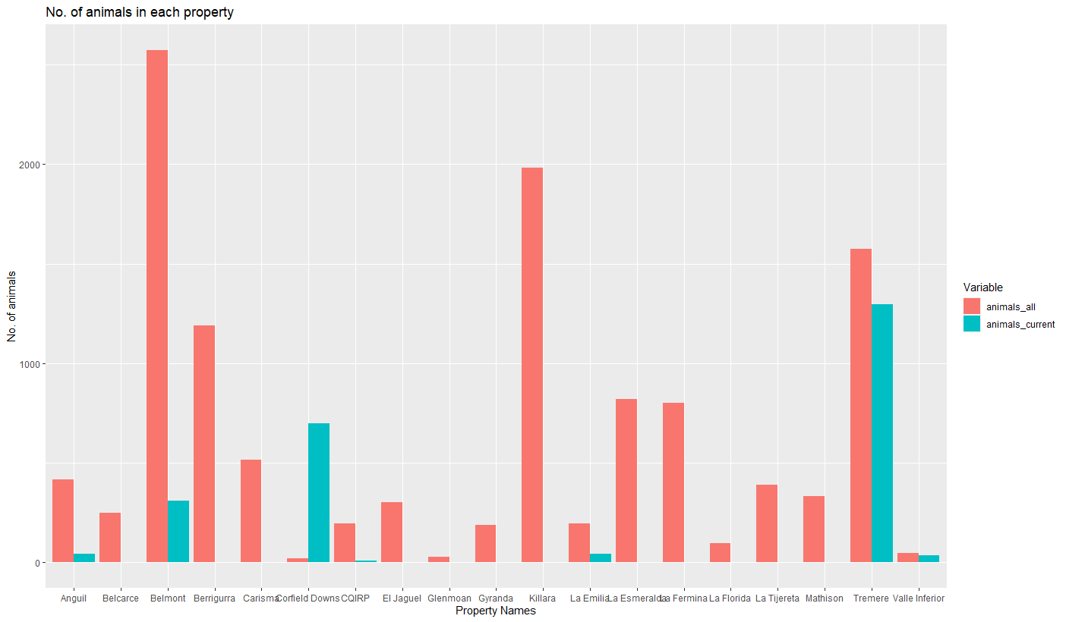

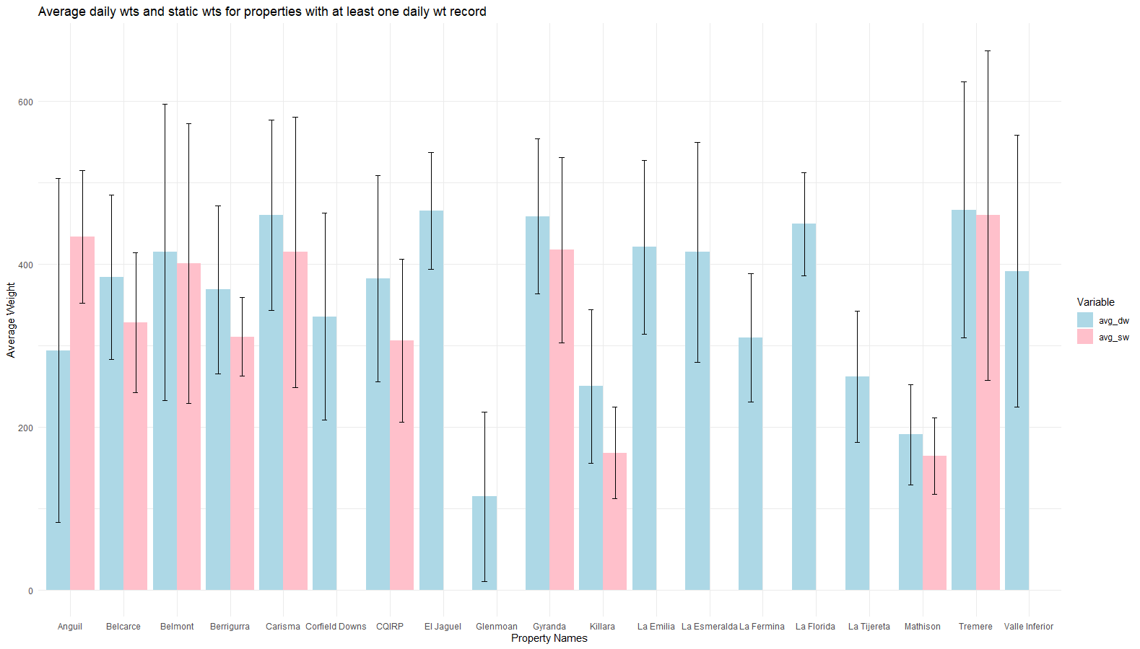

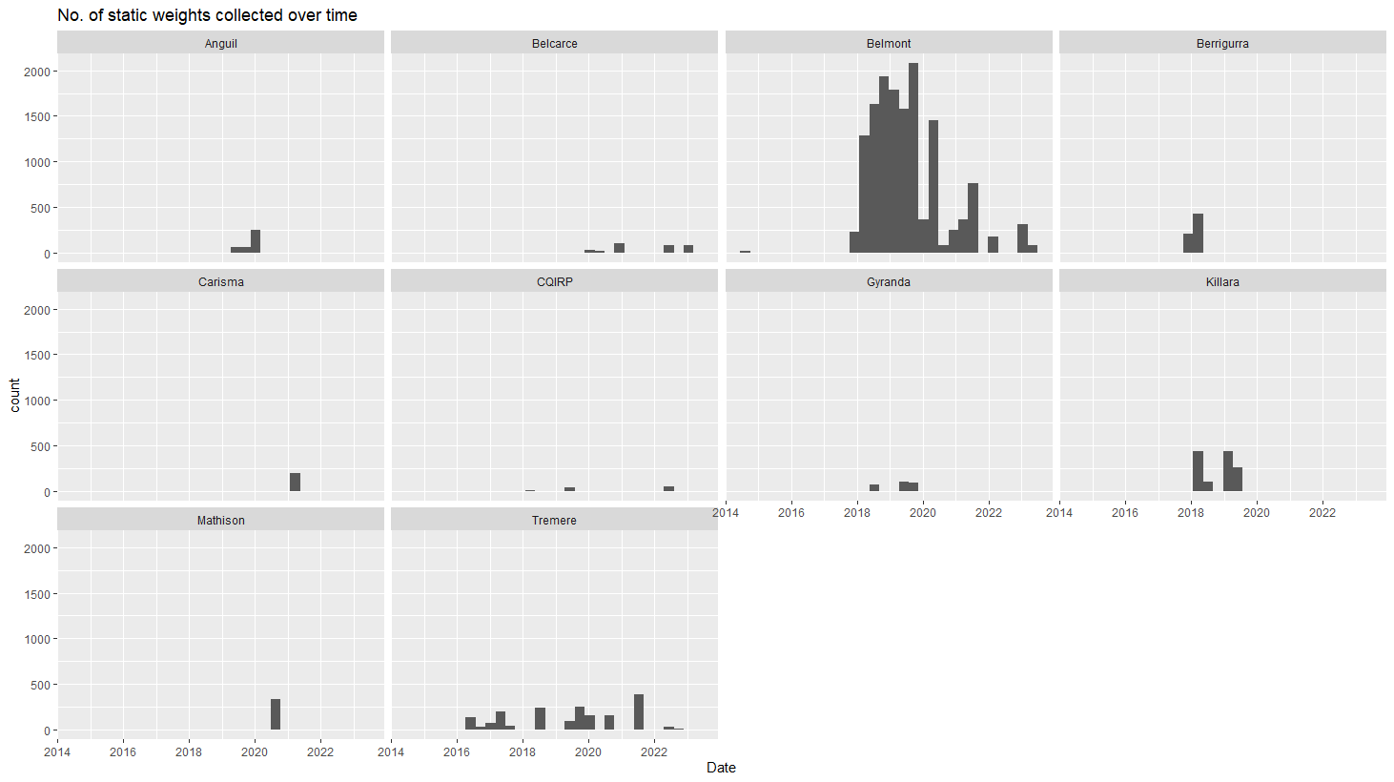

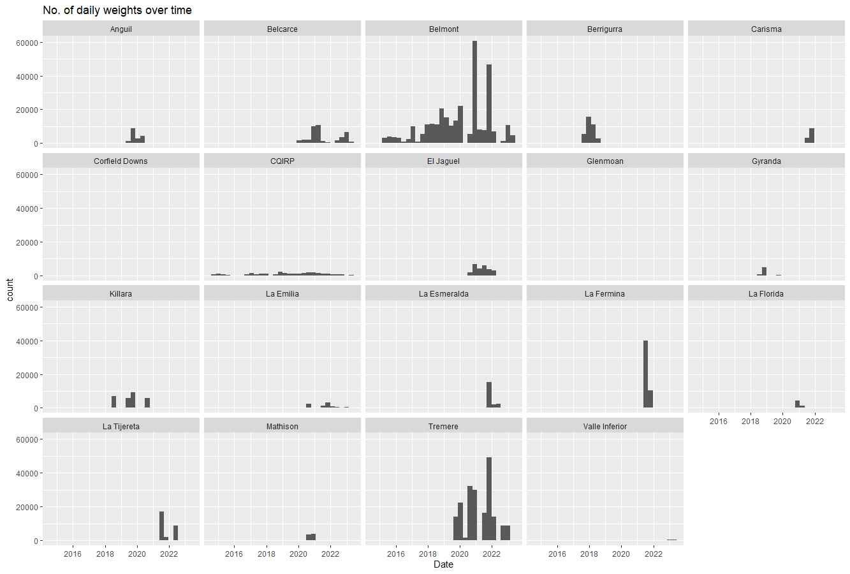

# CQIRP

Source code: TR_PHD/WOW_analysis/CQIRP.R

**# Static weights CQIRP**

Total no. of static weights = 149

No. of zero weights = 42

No. of non-zero weights = 107

No. of animals with at least 1 static weight = 40

No. of animals with 1 static weight = 1

No. of animals with 2 static weights = 27

No. of animals with 3 static weights = 0

No. of animals with 4 static weights = 10

No. of animals with 5 static weights = 0

No. of animals with 6 static weights = 2

Summary:

Min. Median Mean. Max. SD

195.5 264.0 305.9 534.0 100.15

**# Walk-over weights CQIRP**

Total no. of WOWs = 33,767

No. of zero weights = 6,796

No. of non-zero weights = 26,971

No. of animals with daily weight records = 189

No. of animals with 1-10 wow records = 85

No. of animals with 11-100 wow records = 35

No. of animals with 101-1000 wow records = 68

No. of animals with over 1000 wow records = 1

Summary:

Min. Median Mean. Max. SD

3.5 376.1 381.7 1128.2 123.9

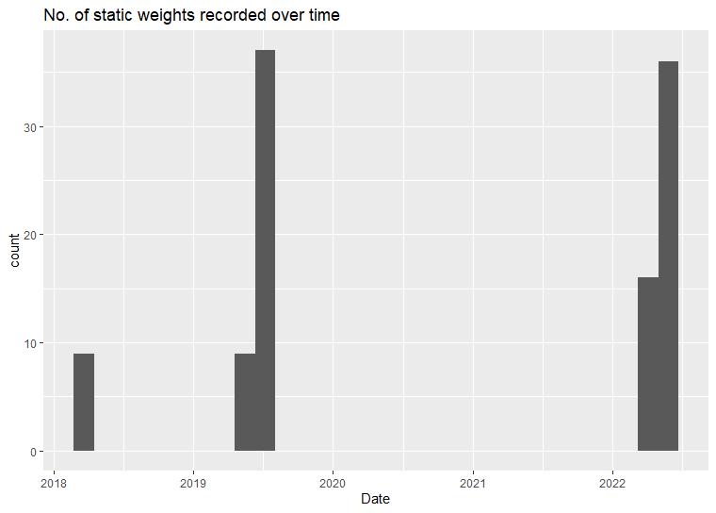

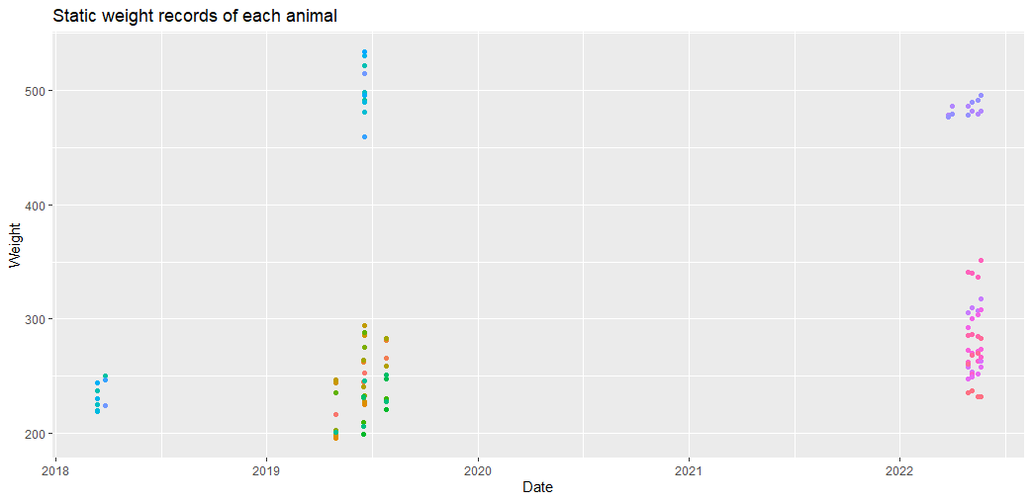

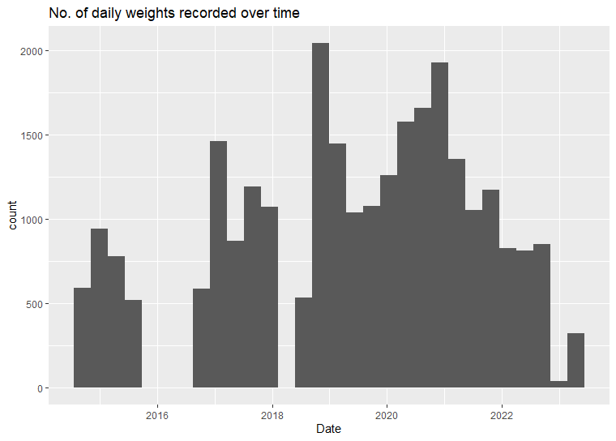

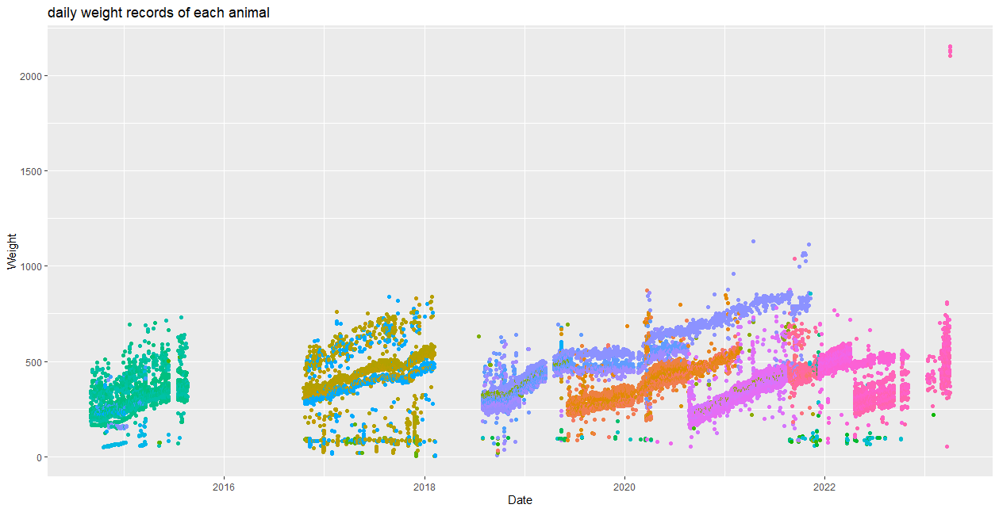

# Methods:

* **Raw data:** The data from each property will be observed to find the data range where there is consistent or sufficient data to used. (Refer to previous plots)
* **Outlier removed data:** Outlier removal will be done first by removing data points with weight of 0 kg, then biologically implausible weights will be removed (eg: weight less than 40 kg and more than 1000 kg and some other criteria)
* **Smoothed data:** The outlier removed data will be smoothed using 7 days rolling average. Or weekly weight data can be used instead.

1. **Repeatability measurement**

* The degree of consistency between repeated measurements under similar conditions; range from 0.0 (least repeatable) to 1.0 (most repeatable)
* Repeatability will be calculated using formula:

R = Vi / (Vi + Vr)

R = Repeatability

Vi = Estimated variance component between animals (weights within 24 hrs)

Vr = Residual or random variance

* Variance components will be estimated using a residual maximum likelihood model (REML). “lmer” function from “lme4” package in r.
* The calculated repeatability will be tabulated as follows:

|  |  |  |  |
| --- | --- | --- | --- |
| Station name | Raw data | Outlier removed | Smoothed data |
| Killara |  |  |  |
| Belmont |  |  |  |
| Gyranda |  |  |  |
| CQIRP |  |  |  |
| Berrigurra |  |  |  |
| Carisma |  |  |  |
| Mathison |  |  |  |
| Tremere |  |  |  |

1. **Accuracy measurement (Agreement of walk-over weights with static weights)**

* Concordance correlation coefficient will be calculated to assess the degree of agreement between automated and static weights.
* The r package “cccrm” can be used.